Theodore Koby-Hercsky

01/26/2023

DSC680-T301 2233-1

Professor Catie Williams

**Milestone 2 – Draft White Paper**

**Github:** [**Sentiment Analysis Car Brand Reviews**](https://github.com/TheodoreKoby-Hercsky/Portfolio_TheodoreKoby_Hercsky/tree/main/Sentiment%20Analysis%20Car%20Brand%20Reviews)

**Business Problem**

When it comes time to choosing a car it can be a big decision that can be overwhelming for some as now a days there are so many car brands to choose from. Problems customers are running into are finding a way to filter out what you are looking for and not looking for in a car as the choice you make can be a large financial impact that can last for several years. The business problem this report will be aiming to solve is provide customers with ease of mind by deciphering reviews from each brand to determine the true benefits and drawbacks one might face when purchasing a vehicle. The use of sentiment analysis will allow customers to analyze mass amounts of reviews to determine the true feedback for each brand. While car brands can also take advantage of sentiment analysis to determine what is working for their company and what they need to improve on. Overall, the goal for this report is to help customers and or brands to decipher the reviews given to provide a true depiction of what you are signing up for when you purchase one a vehicle.

**Background/History**

The data set that I will be utilizing contains review data for five different car brands Audi, Lexus, Infiniti, BMW, and Mercedes-Benz. The data set includes five variables which include the rating, car ear, brand name, date, and review that can be seen below with a brief description of each in the data dictionary. The data was pulled from Kaggle and the date ranges from 1997 to 2018 for the year the car was built. The five car brands that are used are all in the luxury brand field with Mercedes, Audi, BMW being on the pricier end for the most part. While some customers might have done some research on car rating given J. D. Powers as they focus on “quality and reliability ratings are a combination of quality and dependability scores.” (J.D.) While the quality scores are based “on initial owner response and feedback of their new purchase whereas Dependability scores focus on longer-term ownership experiences of 3 years.” (J.D.) Overall by reviewing each car brand and performing sentiment analysis on all reviews the goal is to gain a deeper understanding of the positive and negative feedback of each brand to determine the optimal choice for all customers.

**Data Explanation (Data Prep/Data Dictionary/etc)**

The data I went with focuses on the [reviews of five car brands](https://www.kaggle.com/datasets/ashisparida/reviews-of-5-car-brands) from Kaggle for luxury car brands such as Mercedes-Benz and BMW. The variables that are included in the data set consist of the rating which is displayed as a numeric value that ranges from one to five while another variable is the review which is written by the customer that is regarding the car they purchased. When viewing the dataset, it was determined that all personal identifiable information was excludes in the dataset which allows for accurate reviews of each brand an no way to track a review back to a single user.

Data preparation was needed for further exploration of the date set using describe a “method returns description of the data in the DataFrame” which indicated that the mean rating came in a 4.47% which can be seen below in figure one. (W3Schools) The use of function [isnull()](https://www.w3resource.com/pandas/isnull.php#:~:text=The%20isnull()%20function%20is,arrays%2C%20NaT%20in%20datetimelike).&text=Object%20to%20check%20for%20null%20or%20missing%20values) was also used to “detect missing values for an array-like object” in the DataFrame which indicated that no missing values have been detected as seen in figure two. (Pandas) The use of unique also came in handy as it allowed me to view each brand that was listed in the DataFrame which indicated the five brands that would be reviewed seen in figure three. Next I decided to create a quick sentiment rating just to see what I am dealing with by using an if and elif statement. This statement separated the reviews to either a one or a zero depending on the rating seen in figure four. Next, I will take you through the methods I used to conduct further analysis on the reviews provided.

**Methods**

The use of natural language processing is the first step I will take before conducting any sentiment analysis. These steps include but is not limited to tokenizing sentences, removing stop words, normalizing words, and vectorizing text. The first step that was implemented was lowercase which applied lambda to the reviews to implement lowercase to all letters. Next, I removed all punctuation through the use of strip, split, and apply as seen below in figure five. Once all punctuation was removed I continued by removing all imbedded numbers by using isdigit() and apply which is also seen below in figure five.

Another important process is tokenizing a sentence which is the breakdown of text into sentences, words, and other units. Next is the removal of stop words such as “if”, “but”, and “or” while indicating for the function to keep brand names such as Audi, Lexus, INFINITI, BMW, Mercedes, and Benz seen in figure six. Vectorizing text is also used which is the process of “turning the text into a numerical representation for consumption by your classifier.” (Stratis) Last, I will use VADER sentiment analysis which is a “lexicon and rule-based sentiment analysis tool that is specifically attuned to sentiments expressed in social media.” (Ankthon) Seen in figure seven which was used to create polarity and rating that will produce a in depth score rating and a finer scale indicating positive, negative, or neutral for the Vader polarity.

The creation of visualizations was the next step which started with a seaborn bar plot that used the variables brand name, rating, and car reviews. Which can be seen in figure eight that shows the average rating received for each car brand that showed all brands with an average rating of around four out of five with Lexus with a little higher of an average. A countplot was also created using seaborn that showed the number of reviews by year of the car model seen below in figure nine. Showing that car models from 2004 had over 3,000 reviews while cars from 2012 had just over 500 reviews. Another visualization that was utilized was from plotly express and was a scatter plot that showed Vader rating by brand and date. Seen in figure fifteen it shows that mass amounts of reviews by ratings throughout the years for all brands. Which shows that some brands like Infiniti, Lexus, and Audi had the least number of reviews compared to BMW and Mercedes. Last I created two bar plots with matplotlib to show the rating count percent with the original rating variable and the polarity Vader review rating. Figure ten shows the bar chart for the original variable rating shows 54.36% of all reviews being a rating of 4 while ratings one, two and three add up to only 15.01%. While in figure eleven shows that all positive reviews add up to 86.69% while negative and neutral reviews only add up to 13.31%.

**Analysis**

Modeling is the next step in this report that starts with the creation of X and Y for the target and predict variables. As the target variable for this report is the updated review which is being used as the X while the Y is the predict which uses the review polarity as Y. Next, I printed the shape of the X and y for both test and train. The x and y train has 19,162 values with one variable while the x and y test shows 12,776 values with one variable. Next I went on to creating TF-IDF which stands for “Term Frequency – Inverse Document Frequency and is a statistic that aims to better define how important a word is for a document.” (Borcan) Seen in figure twelve the creation of the x train vector which has a shape of 19,162 and 21,980 that was created with fit transform.

The first model that was used is the Logistic Regression that aims to “solve classification problems by predicting categorical outcomes.” (W3Schools) Seen in figure thirteen it shows with the use of logistic regression and the x train vector created an accuracy of 91.49% which is a great start. The next model I used was the Random Forest Analysis a “supervised learning algorithm that can be used both for classification and regression and is flexible and easy to use.” (Navlani) The creation of the random forest classifier model showed an accuracy of 99.95% that can be seen n figure fourteen. Overall, it is seen that the random forest model had the highest accuracy compared to the logistic regression model.

**Conclusion**

The two models had great findings that both landed in the 90 percentile for accuracy while the Random Forest mode had an accuracy of 99.95% while the Logistic Regression had an accuracy of only 91.49%. Overall, both models are great options, but I would like to do some further research on each car model to complete further evaluation for my final submission. In the meantime, a user’s best option would be the random forest classifier when performing sentiment analysis on reviews, but it is best to use several models to see the best outcome for one’s data.

**Assumptions**

The assumptions that can come from the findings in this project is that the largest number of reviews come from cars that are from 2004 with over 3,000 reviews while cars created in 2012 showed the least amount of reviews with only a little over 500 being submitted for the brands from this data set. An assumption that can be seen is that as the years go on the amount of reviews have decrease and there is less issues customers are running into. While most ratings range from a four to five with only 15% being neutral or negative for reviews. Meaning that car brands are seeing good reviews but need to read between the lines to find what customers are looking for and want to stay around in the new cars to come.

**Limitations**

The limitations that I have ran into and noticed with the data set is that there is only luxury car brand which indicates reviews from wealthier consumers. While the reviews given are few in comparison to what should be seen for the year range that the cars are coming from. While the reviews seem to mostly be positive which limits the number of negative reviews seen within the data. Overall, the data limits users to knowing all facts given on the car brands over the years which could hinder their choice in companies to go with for their next vehicle.

**Challenges**

The challenges I see when it comes to sentiment analysis for car brand reviews is that users will see positive and negative reviews for each company but in the end they will need to weigh the options and decide on what they can and cannot live with in their next vehicle. While on the car brand side the companies that use sentient analysis will need to view their reviews and determine the big picture behind them such as outdated technology, engine issues, and more. As BMW has seen reviews regarding outdated technology which is a great start for where they can implement improvements to raise customer satisfaction. The challenge with this is companies take several years to implement changes in their cars as it takes time, testing, and resources to make changes.

**Future Uses/Additional Applications**

Future use for this project can be used on any reviews one might come across being in the car brand area or even other areas such as book reviews, product reviews, and more. While this report can also go into mor details on each car brand which I am going to look into for the final submission to help see the difference between each brand in reviews. While for use on the car company side managers and analysts can use this project to further evaluate their cars and determine what features they are missing and what they can do without.

**Recommendations**

The recommendations that can be given are that all car brands have around an average rate of a four out of five. While Lexus has seen the highest ratings while Infiniti and Mercedes seem to have the lowest rating due to a larger number of lower ratings. While in recent years cars that where built in 2016 showed the highest numbers of rating within the last ten years with over 1,000 given. With that being said I would steer clear of cars from 2016 due to the large number of reviews within the years. While in conclusion I would advise users to research further into the brands they are thinking of purchasing and weighing out the god and bad in all companies.

**Implementation Plan**

The plan for implementation on the car company side would be for analysts and managers to use sentiment analysis on the reviews the receive and determine what the can work on fixing and what the need to keep to retain current customers and gain new ones. While customers will need to conduct sentiment analysis on car company reviews that they are interested in purchasing to determine the best brand to go with.

**Ethical Assessment**

An ethical assessment can be conducted on each car brand by analyzing the reviews they receive ethically and determine the best course of action for each department within the company. While auditing their reviews on a monthly basis and follow up with departments to verify improvements are being made. Hopefully by analyzing reviews and auditing each department companies can have a chance to improve on processes and their company.

**Data Dictionary**

* **Rating** - A numeric variable that gives the car brand a rating of one to five.
* **Car_Year** – The year the car was built.
* **Brand_Name** – Is the brand such as Audi, Lexus, Infiniti, BMW, or Mercedes-Benz
* **Date** – Is the date the owner of the car created the review.
* **Review** – The review given by the costumer regard the car they purchased.

**Figures**

* Figure 1: Table

  Description automatically generated
* Figure 2: Graphical user interface, text, application

  Description automatically generated
* Figure 3: A picture containing calendar

  Description automatically generated
* Figure 4: Text

  Description automatically generated
* Figure 5:

* Figure 6:

* Figure 7:

* Figure 8:

* Figure 9:

* Figure 10:

* Figure 11:

* Figure 12:

* Figure 13:

* Figure 14: Graphical user interface, text, application

  Description automatically generated
* Figure 15:

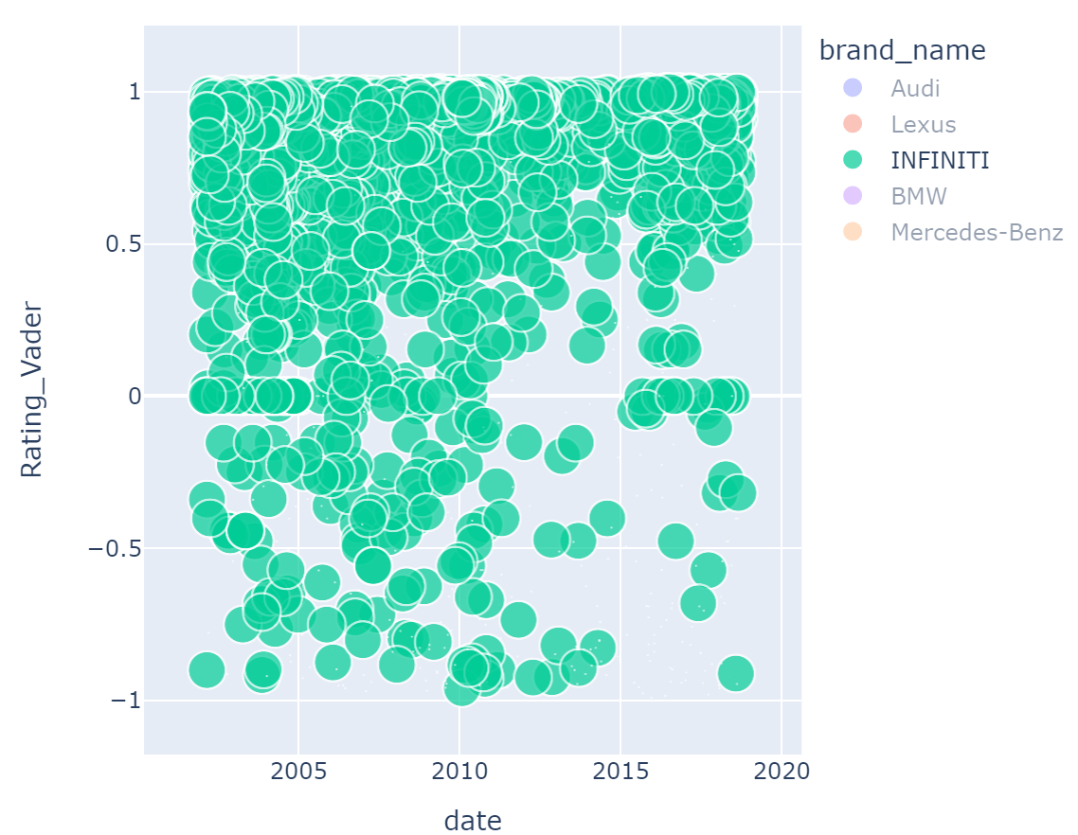

**Citations**

J.D. Powers. (n.d.). *Car ratings and awards: J.D. Power Awards and ratings*. Car Ratings and Awards | J.D. Power Awards and Ratings. Retrieved January 22, 2023, from https://www.jdpower.com/cars/ratings

Parida, A. (2021, August 24). *Reviews of 5 car brands*. Kaggle. Retrieved January 22, 2023, from https://www.kaggle.com/datasets/ashisparida/reviews-of-5-car-brands

W3Schools. (n.d.). *Pandas DataFrame describe() Method*. Pandas dataframe describe() method. Retrieved January 22, 2023, from <https://www.w3schools.com/python/pandas/ref_df_describe.asp>

*Pandas isnull() function*. w3resource. (n.d.). Retrieved December 6, 2022, from <https://www.w3resource.com/pandas/isnull.php#:~:text=The%20isnull()%20function%20is,arrays%2C%20NaT%20in%20datetimelike).&text=Object%20to%20check%20for%20null%20or%20missing%20values>

*Stratis, Kyle. “Use Sentiment Analysis with Python to Classify Movie Reviews.” Real Python, Real Python, 10 Nov. 2022,* [*https://realpython.com/sentiment-analysis-python/*](https://realpython.com/sentiment-analysis-python/)*.*

*Ankthon. “Python: Sentiment Analysis Using Vader.” GeeksforGeeks, 7 Oct. 2021,* [*https://www.geeksforgeeks.org/python-sentiment-analysis-using-vader/*](https://www.geeksforgeeks.org/python-sentiment-analysis-using-vader/)*.*

*Borcan, M. (2020, June 8). TF-IDF explained and python sklearn implementation. Medium. Retrieved January 25, 2023, from* [*https://towardsdatascience.com/tf-idf-explained-and-python-sklearn-implementation-b020c5e83275*](https://towardsdatascience.com/tf-idf-explained-and-python-sklearn-implementation-b020c5e83275)

*W3Schools. (n.d.). Machine learning - logistic regression. Python Machine Learning - Logistic Regression. Retrieved January 25, 2023, from* [*https://www.w3schools.com/python/python_ml_logistic_regression.asp*](https://www.w3schools.com/python/python_ml_logistic_regression.asp)

*Navlani, A. (2018, May 16). Sklearn Random Forest classifiers in python tutorial. DataCamp. Retrieved January 25, 2023, from* [*https://www.datacamp.com/tutorial/random-forests-classifier-python*](https://www.datacamp.com/tutorial/random-forests-classifier-python)